|  |  |  |  |
| --- | --- | --- | --- |
| X | 0.33333 | 0.25 | 1 |
| F(x) | 2 | -1 | 7 |

**Input:**

**Output:**

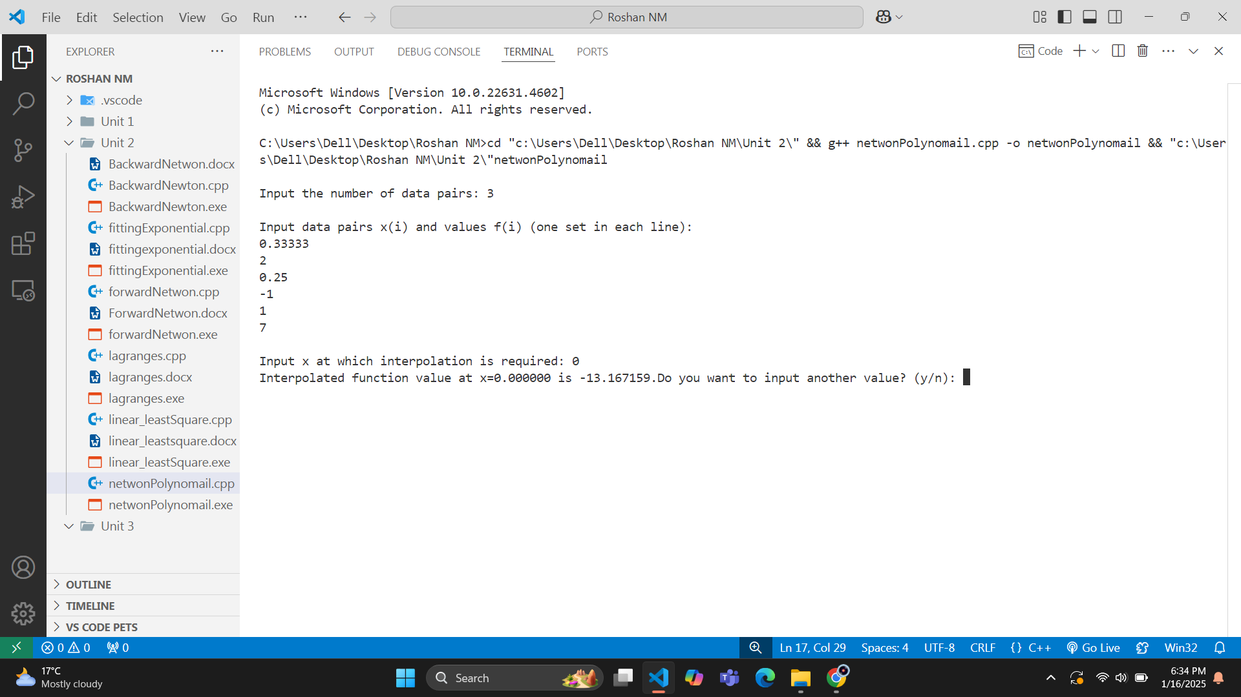

|  |  |  |  |  |
| --- | --- | --- | --- | --- |
| X | -1 | -2 | 2 | 4 |
| F(x) | -1 | 9 | 11 | 69 |

**Input:**

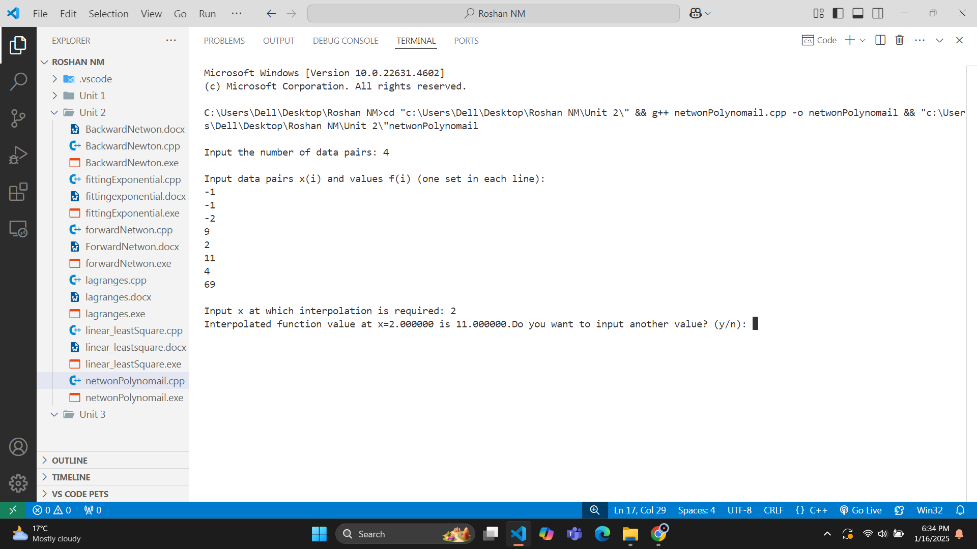**Output:**